Course Announcement  Method Validation & Quality Control  Regional Training of Trainers Workshop (non-Teachback) | 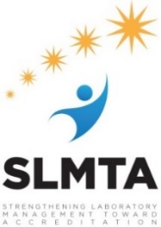

Surname (Family Name):
Given Names:
Dr./Mr./Mrs./Ms.: | Gender:
Address:
Country:
Work Telephone: |  | Mobile:
Email: |  | Alternate Email:
Employer: |  | Job Title:

Answer the questions below. Keep your reply within 5 lines or 5 bullet points.
Please briefly describe your Quality Control and Method Validation experience and training.
Please briefly describe your plans to step this training down in your country.
I will be sponsored by (please check one):
___ CDC
___ Employer
___ Other (please specify) ___________________

Financial Proof Letter or Email Attached:
___ Yes
___ No

